Recruitment Week:

Energizing Youth Groups

with New Voices*

This Activity Focuses On
- Teamwork
- Including and accepting others
- Leadership

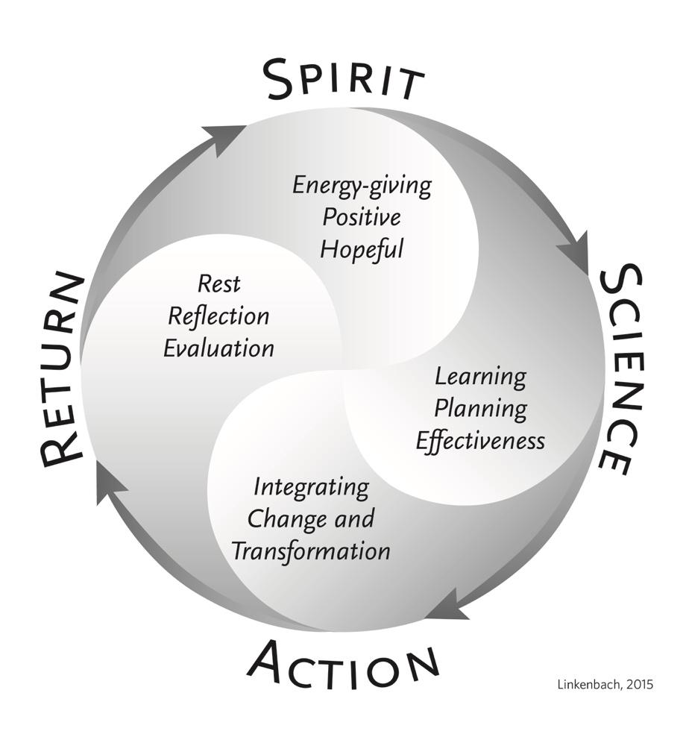
*Pre-requisite:
Complete the Communication Channels: Where are YOUth? Activity First

Setting the Stage
In recruiting new members, there are no good or bad experiences — just learning experiences. There are many different ways to engage in the recruitment process, and by listening to young leaders you can create a fun and effective process. In this activity, we will use the entire Cycle of Transformation as a guide.
This activity falls under the domain of Action and relates to Core Principle #6 — Be Proactive.
To be Proactive is to actively choose where we place our attention and what actions we will take. By noticing what is happening - reactions both inside and outside ourselves - we transcend reaction and can instead choose whether and how to respond to our circumstances. This process produces an experience of hope; we trust ourselves within the natural ebb and flow of life without having the illusion that we need to be in control. When we misperceive or fail to trust, we need to be in control because we’re afraid reality is determined by what happens outside ourselves.

Duration
20 minutes

Goals
Participants will:
- Work as a team
- Recruit new members

Materials
- Science of the Positive (SOTP) Cycle of Transformation poster
- Results of the Youth Communications Channel Survey

Getting Ready
- Before doing this activity, administer the Youth Communications Channel Survey with the student population. See the Communication Channels activity for more information.
- Display Cycle of Transformation poster where participants can see it.

Activity
To prepare for recruitment week, it is important to know where and how students receive information. Begin with the statement below to the youth.
Remember the Youth Communications Channel Survey? The results of that survey can help us with recruitment, by giving us information on the best way to reach out to youth who might be interested in joining.

Let’s look at the results of our survey.
Bring the full group together, assembling in a circle if possible. Share the survey results on a handout or on the board. Start the conversation with questions like:
- What results in the survey stand out to you?
- Do you see any patterns in the results?
- What can we learn from this data to make recruitment week more successful?
- Do you think it would be helpful if we refined the survey, or conducted it again to gather more responses?
Once you answer the questions above — and before the recruitment week begins — use the Cycle of Transformation to guide your planning. Begin with the statement below to your students:
SPIRIT:
Let’s start with Spirit. Successful recruitment is all about our passion for our program. It’s also about branding.
- What image or feeling do we want people to have about our group?
- What are we passionate about? Who are we?
- Why do we want new members?
- Why did you get involved with the group?
Let the group discuss the above, and write down their responses. You may want to use their ideas to create a poster, flyer or social media post that speaks to who and what your group is about.
SCIENCE:
- What do we want people to know about our group?
- Are there particular data points or other information we want to share?
- What’s our purpose?
Write down responses for discussion. You may want to create a poster, flyer or social media post that speaks to the science behind your group’s efforts.
ACTION:
Let’s go through what we discovered from our survey.
- What approach should we use to recruit new members?
- What are some details we need to work on?
- What events are coming up at our school that we could be part of? Are there groups that make sense to partner with? Let’s make a wish list.
- What weeks work best?
- Do we want to hold several recruiting events, or do we invite students to a recruitment meeting?
- What are some good incentives to get students excited about becoming part of our group?
- Should individual group members make personal invitations to fellow students they want to join the group?
- Could recommendations to join the group from adults — including, teachers, coaches, etc. — be an effective recruiting tool?
- Share your recruitment plan with the school’s administration.
Let the group discuss the above and assign roles, responsibilities and due dates to make your recruitment event happen.

Variation
Depending on the results of your Youth Communications Channel Survey, recruitment week can be a one-time event or take place over several events over the course of a week. For example, your group could host a one-time recruitment party, inviting others to join via flyers, social media, or personal invitations. A week-long recruiting process might involve your youth group collaborating with other groups in co-hosting several sign-up events. What you do may depend on your budget, access to youth, time of year, etc.

Talk About It
RETURN: After your recruitment event or events, take 10 minutes or so to reflect on how it went as a group. Here are some discussion points:
- What went well during recruitment? What could we do better next time?
- How did it feel to recruit other students?
- Were people receptive to your invitation?
- What image or feeling do you think people have about our group now?

The Big Next
Re-evaluate after three months to determine how effective your recruitment week was.
- What was the result of our effort? Did our group grow?
- Do we need to do another recruitment week?
- What can we incorporate from what we learned the first time?

